NATIONAL UNIVERSITY OF MODERN LANGUAGE ISLAMABAD
Lab task:-07


Submitted to:
Mr. Meesam Raza
Submitted by:
Zulqarnain Hassan
Roll No: …………………… SP21379
Subject: …………………… Operating System
Department: ……………… BSSE-4-Afternoon
Date: ………………………. 28-04-2024

Task 01

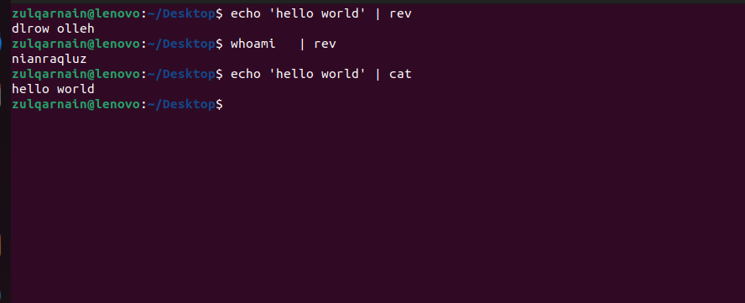

Task 02

